Book Interface

Sabrina Kabir

March 2026

Table of Contents:

Introduction of Book Interface 2

Analysis of the Problem 2

Current State of the Interface 2, 3

Desired Future State 3

Alternative Options 3

Project Planning 4

Design and Development 4, 5, 6

IT Infrastructure of the Project 6, 7

Data Architecture of Interface 7

Application Interface/Interaction 8, 9

Testing Methods 10

Professional Responsibilities 10

Ethical and Legal Issues 10

Support and Integration 10, 11

Conclusion 11

References 11

Introduction of the Book Interface

This project is intended to be a custom final project developed for my Capstone II class. The project idea was curated through my appreciation for reading. I wanted to develop a project that other readers could utilize as a tool. The main purpose of the book interface is designed to minimize a user’s searching time of doing book research.
The book interface is situated as a non-profit project. Another important goal for this project is to offer readers around the world an option to find more information about book(s) without having the need to open multiple tabs at one setting. Through this book interface, users will have the opportunity to find an array of information about a book such as book title, author’s name, first published year, book cover image (if retrieved), and summary (if retrieved). The user can find more information about a book by searching through the name of the book title, author’s name, or a general subject.

Analysis of the problem

When it comes to doing research to buy or read a book, users often like to have multiple tabs open to compare a book against another. This webpage interface will allow users to find multiple information about a book in one sitting. Some examples of the information will state the author’s name, published year, summary of the book, etc. Moreover, instead of finding various information about one book at a time, this interface will be designed to showcase multiple books based on the user’s search criteria.

Current State

The interface will receive information from the OpenLibrary website. More specifically, the interface inputs will send out API requests to the OpenLibrary server. In return, once the information has been retrieved from the OpenLibrary, the interface will be able to display a limit of three books according to the user’s input.

The user interface displays three different search boxes that the user can use to search information about a book through. The listed search boxes include: the title of the book, author’s name, and general subject. However, it is essential to note that the user should not input data using more than one search box in order to avoid receiving mixed results. An alert message was attempted to add in the interface that would have indicated that the user has to input one of the boxes should the user inputs data into more than one search box. However, this alert message has not been edited further to function in the current book interface due to a shortage of codespace usage available to use.

The entirety of this project is developed through the Github codespaces environment. Through this environment, I possessed the ability to monitor and test various unpublished functionalities of the project through a live server application installed into the codespace itself.

Analysis of the Desired Future State

Initially the general plan had included several details about a book to be displayed once retrieved through the user’s input and API calls. Details of the book’s information had included the book’s title, author’s name, summary, price, published year, and edition. The price component had to be removed as the project was developed, since the API did not include that aspect. In addition, the edition count was also removed from the list of information received because a lot of books don’t have multiple editions.

Github codespaces will remain as the main coding environment because it allows me to publish the project and project’s changes easily to the web. The final project can be viewed through a published website made through Github.

Alternative Options

A main criteria for this project was to utilize the Application Programming Interface (API) calls. Therefore, there were no alternative options for this project because other methods, such as directly linking the book to another website, does not include receiving information through API calls.

Project Planning

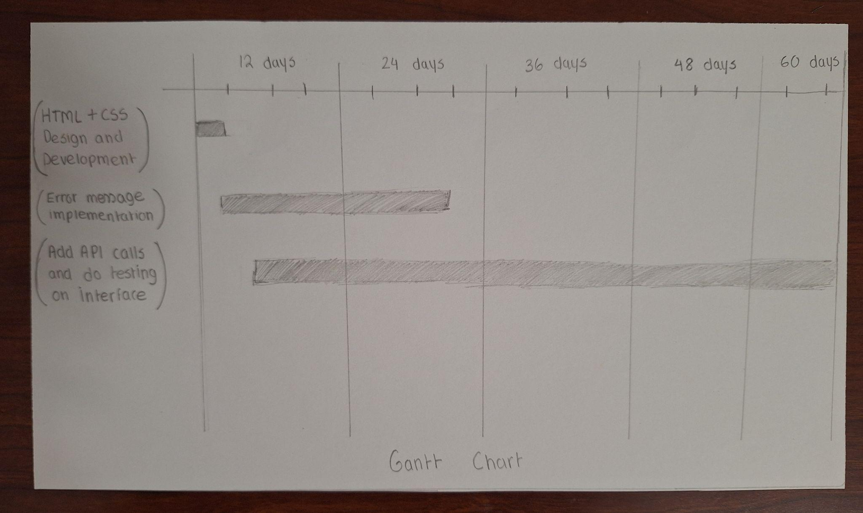

Design and Development

A series of sketches were drawn to showcase what the book interface might look like. The first image describes what the interface looks like before the user has decided to input any data. The show results button helps showcase the list of books once clicked. On the other hand, the clear button is used to remove any pre-existing text on the search boxes or the results section.

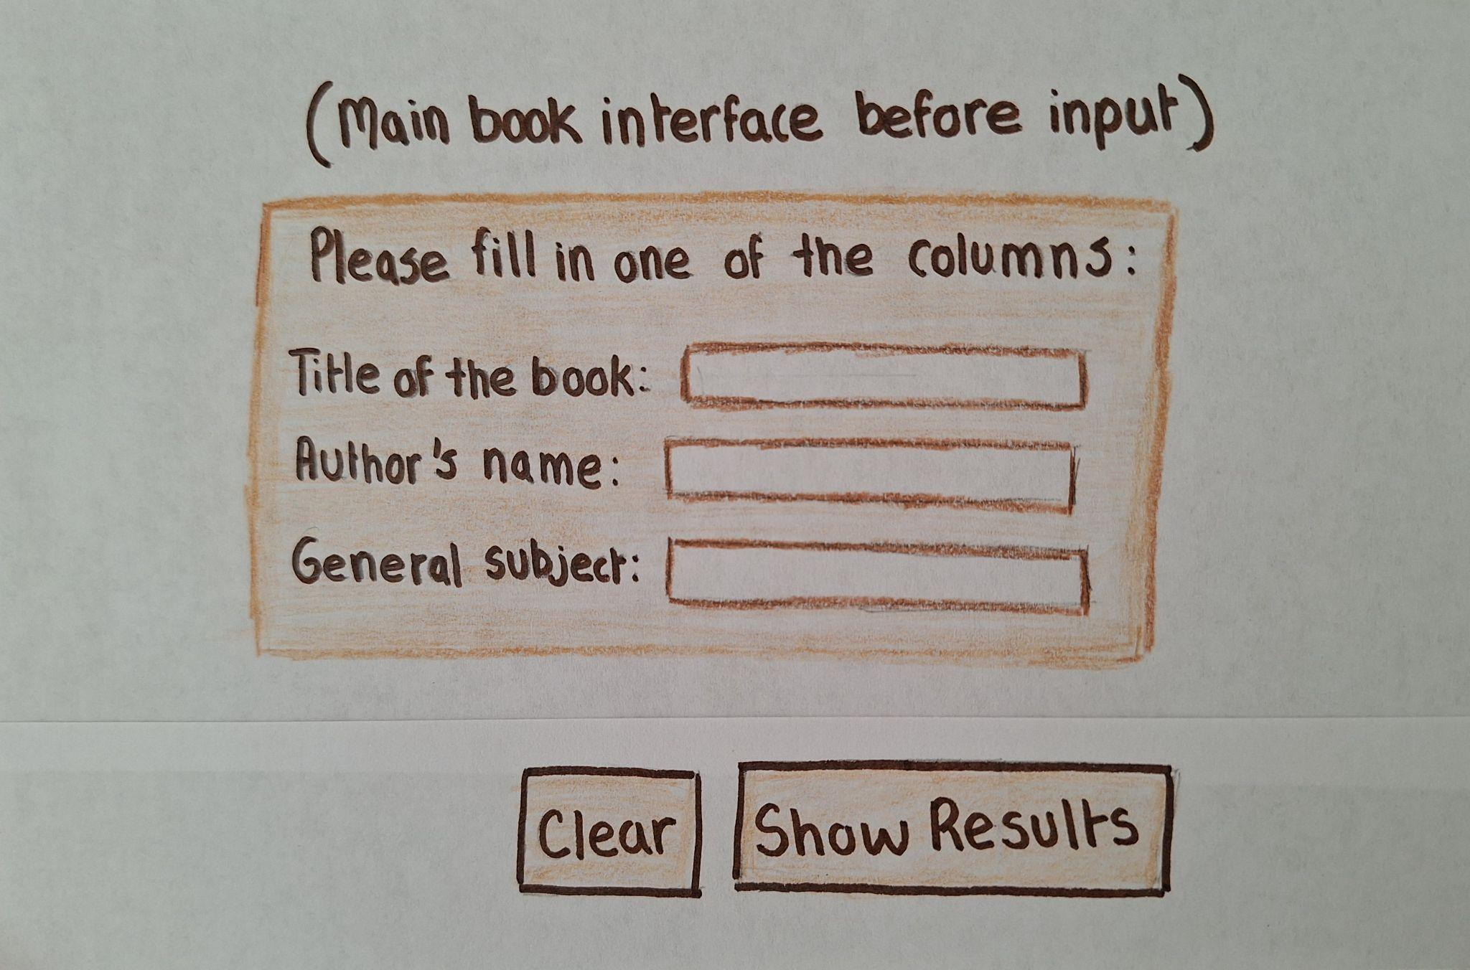

The second image displays the results of an inputted data. It is also important to note that not all displayed results will include a cover of the book itself. The following aspect also applies to all of the other displayed information such as summary, published year, etc.

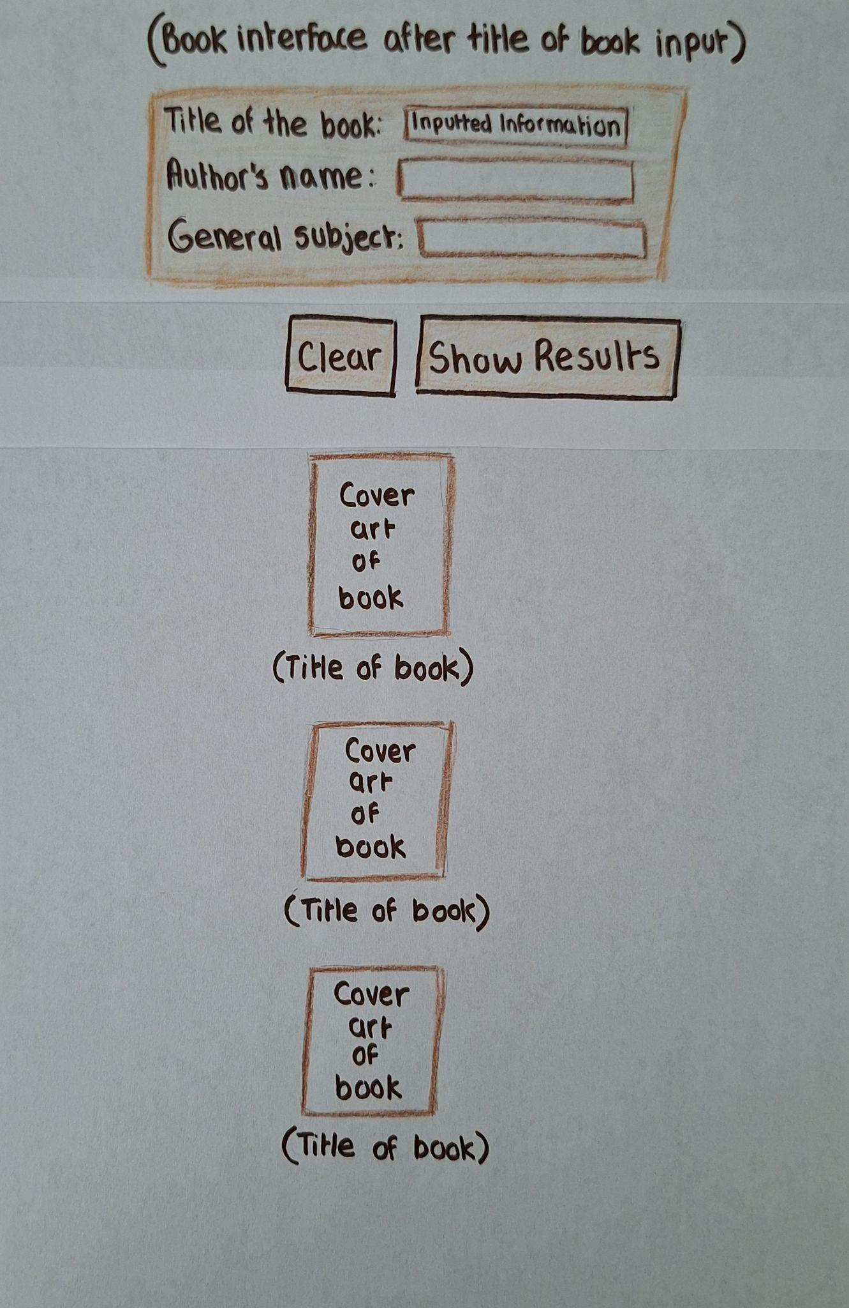

After developing the book interface, its typography, and its color scheme, the results looked like the following image:
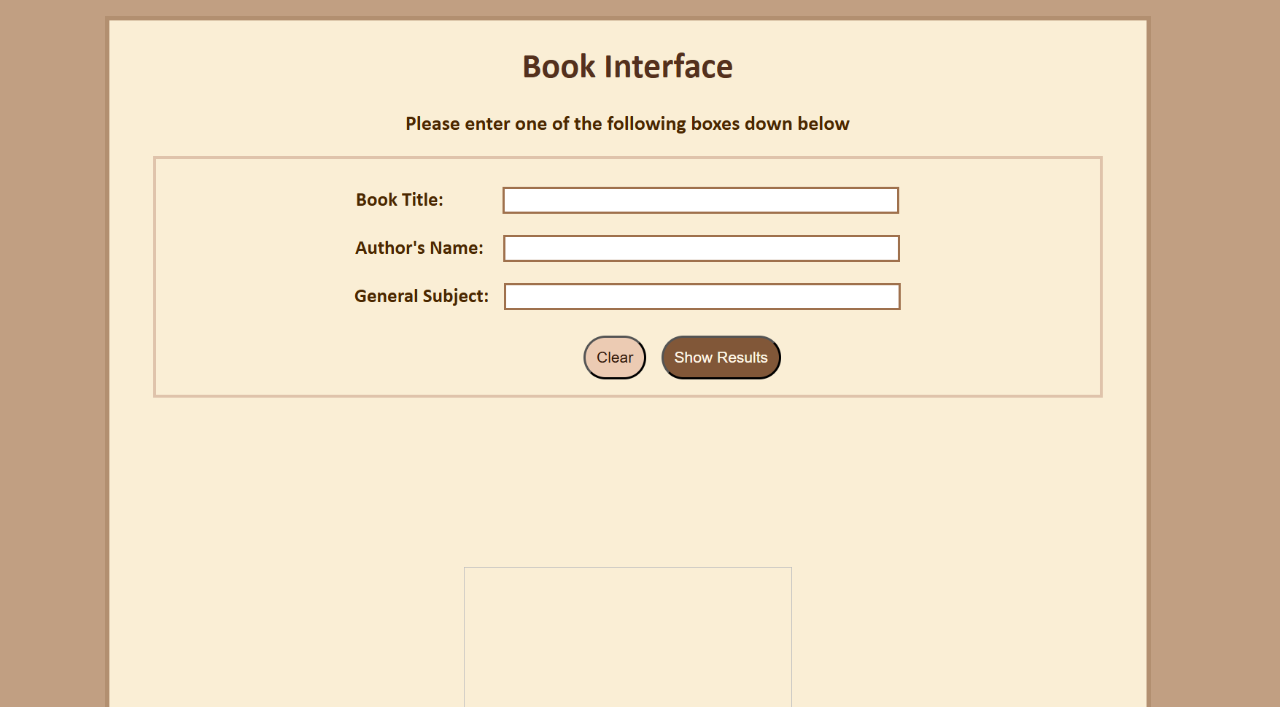

IT Infrastructure of the Project

As mentioned previously, the project was developed in the Github codespaces environment. There are a few key details to note about the Github environment. Since Github codespaces is a cloud-based environment, a steady internet connection was required throughout the scope of the project. A limitation that was also apparent in the Github repository is the limited amount of codespace usage for the month. Once the limit is reached further access to the codespace could be blocked off. Therefore, the project had to be developed under a certain usage amount. Another limitation to this project is how information is being retrieved through API calls. If the server stops functioning on behalf of OpenLibrary, then the information requested by the user may not be retrieved on a timely basis. In addition, the OpenLibrary server can only include one request per second, since the user-agent string is not a part of my code, referencing from the API page in OpenLibrary.

Changes and improvements to the interface were published/pushed constantly in the Github environment to avoid the code being discarded automatically after a week of inactivity. A note was added with each published modification to keep track of the changes made in the last coding session. Unpublished changes to test out the functions were viewed by an installed real-time live server.

Data Architecture of the Project

An Entity-Relationship (ER) diagram was crafted to show the relation between each entity and how each entity for this project has attributes that connect them to other entities. An image of the ER diagram is provided down below:

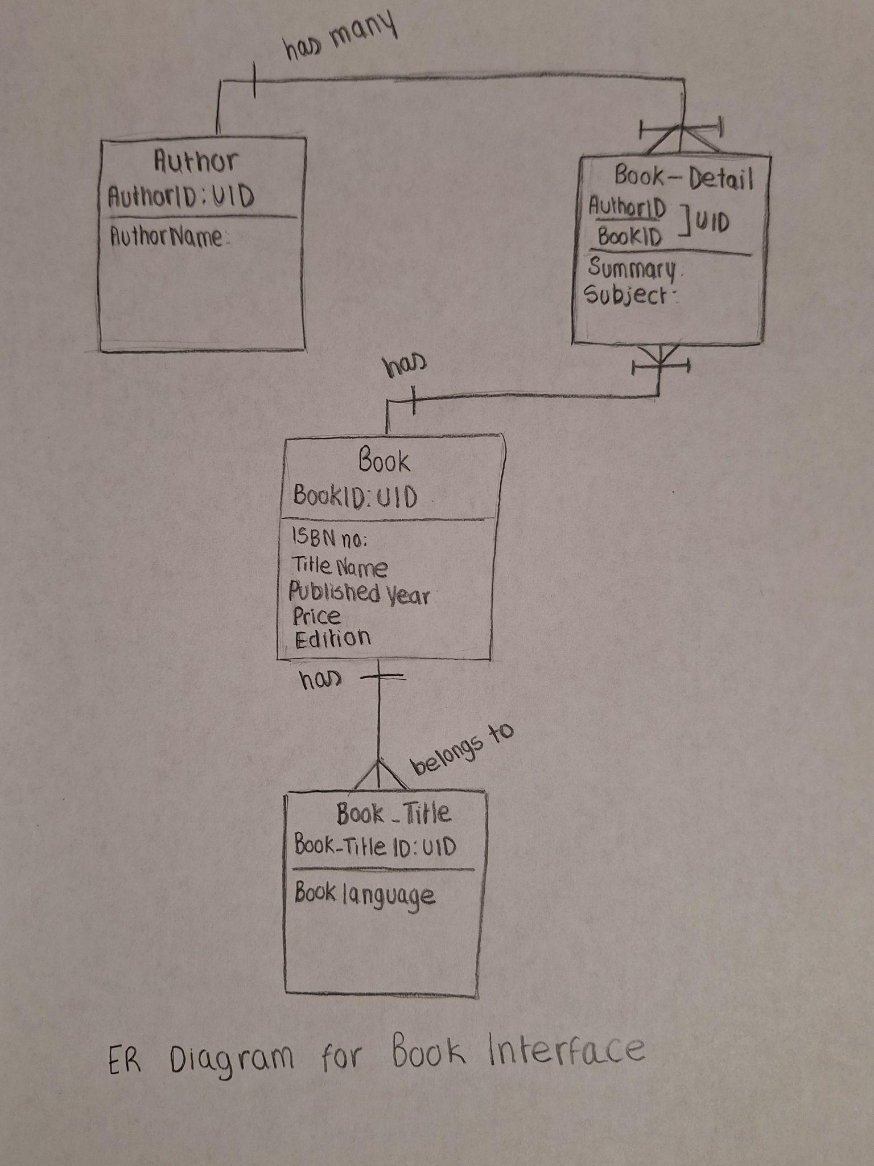

Application Interface/ Interaction

As seen from the previous image of the interface, there are only a few tools that the user can use in the interface. The first interactive element involves the textboxes of book title, author, and general subject. In addition, the other way to interact with the interface would be to use the “Clear” or “Show Results” button. The clear button functions to remove written text from the textboxes and information from the results section from a previous search result. To avoid pre-existing data being included in a new search result, the clear button is encouraged to be used before searching for a new book.

There was an initial plan to embed all of the book’s information inside of the book cover, so users had the ability to click on a book cover to see all the presented information. However, this idea was removed during the development of the project because several books did not have a book cover that was provided by the API calls and allowing users to click on a book for more information would provide more difficulty for users to compare one book with another. Allowing users to scroll through the interface provides a quicker response time for users to find the differences between several books.

The following series of images are an example of what a response from the interface would look like. For this example, the summaries are not provided by the API calls because the description portion of the API did not have a value to display.

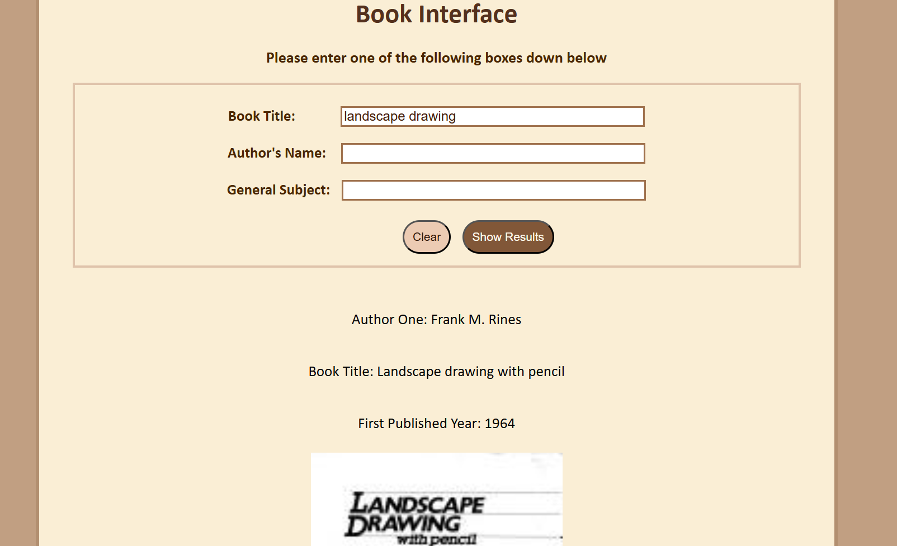

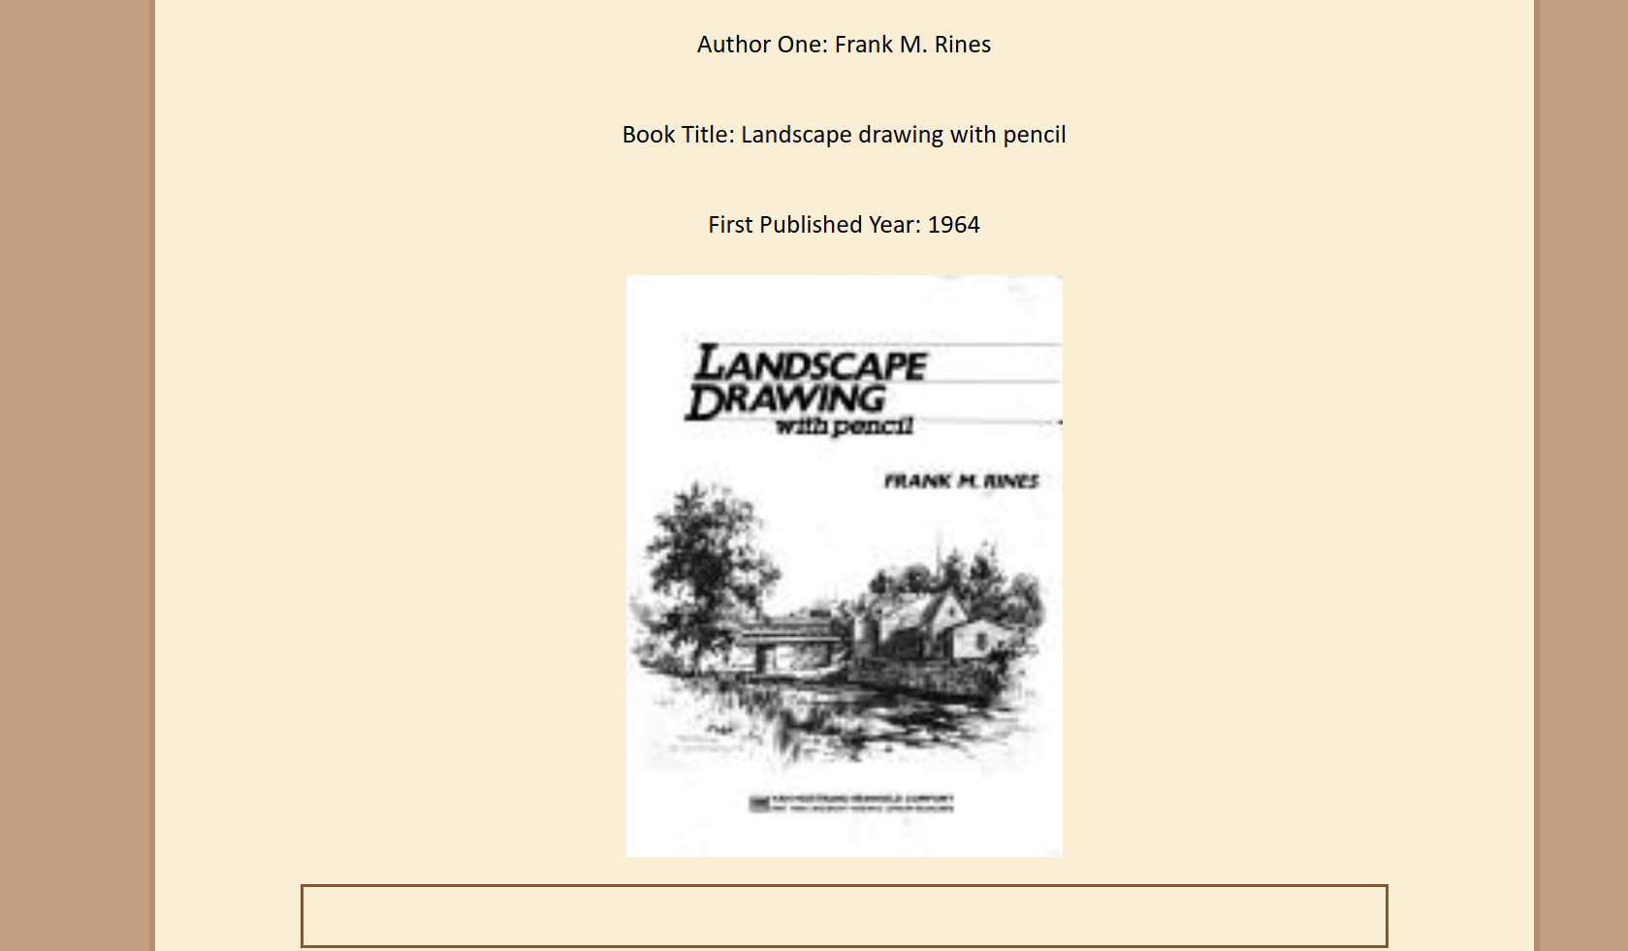

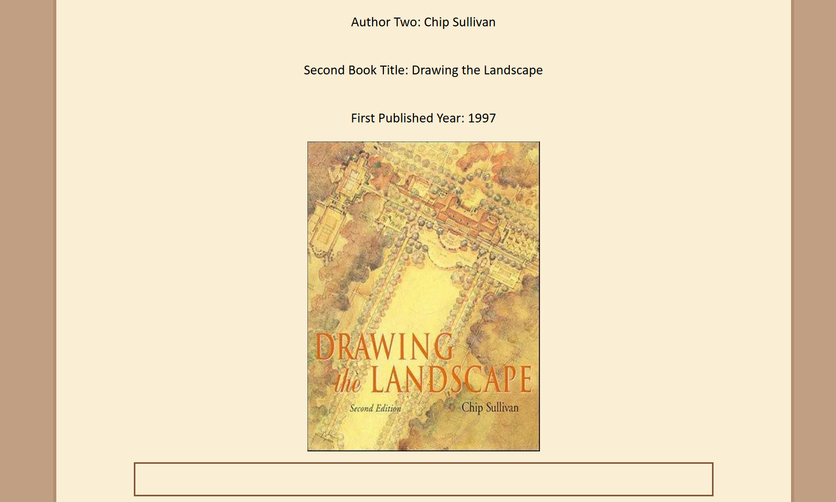



Testing Methods

As mentioned earlier within the report, uncommitted changes were monitored through a live server extension within the codespace environment. This live server extension has allowed me to understand how the data is currently being displayed. In addition to the live server, the debug function available in the chrome developer tool has allowed me to understand how data is reached behind the scenes. Using chrome’s debugging function has allowed me to identify where errors were occurring within my code. In addition, it also lets me view the type of information present within the API calls.

Professional Responsibilities

One of the most essential details about this project was to maintain and complete the work in a timely manner. This project had to be completed before April 30th, 2026. The following statements align very closely with the standards listed in the ACM Code of Ethics and Professional Conduct. More specifically, it aligns with the 2.3 concept of being aware and following established guidelines.

Ethical and Legal Issues

There weren’t any particular ethical or legal issues presented in my project because the data received through the API calls is not sensitive/confidential information.

Support and Integration

This project is published through Github pages. Username changes or deletion of the account hosting the book interface must be avoided in order to keep the current book interface’s url active. Modifications of the account’s page must also be avoided to allow users to find the book interface more easily. The interface can be used consistently over time to see if the API calls are functioning properly. If it isn’t, the debug function will showcase where the code stops functioning.

Conclusion

In this project, I had the opportunity to develop a working book interface. This project helps a user identify extra details about a book such as the name of the author, summary, published year, and book cover. The main purpose of this project is to help users minimize research time when it comes to comparing one book with another version. In addition, this process can help minimize the amount of tabs that a user has open to compare different books. This book interface is currently being hosted within a Github page.

A lesson that I have learned from working on this project is to be aware of the amount of codespace usage that is currently being used in the Github environment. For future references, I thought it would be important to note that planning edits that need to be published ahead of time is important because it can help save on codespace usage. Another lesson that I have learned is double-checking with how values are stored in API calls. For example, the summary portion in the interface was stored as a string value in some API calls and object in others. Therefore, it is best to test an interface with various inputted values.

In conclusion, I am grateful that I had the experience and opportunity to create this book interface. I hope that users will be able to minimize their research time on books by using this interface. In addition, I wanted to thank my professor, Bruce Bauer, for providing his advice and recommendations for this project.

References

Don Gotterbarn, et al. ACM Code of Ethics and Professional Conduct (2018) https://www.acm.org/code-of-ethics

OpenLibrary. APIs https://openlibrary.org/developers/api

OpenLibrary. Search API https://openlibrary.org/dev/docs/api/search

OpenLibrary. JSON API https://openlibrary.org/works/OL45804W.json

